AWS:

EC2: for hardware, VM setup.

VM:

AMI (os, windows, linux/unix)

Instance type/size: RAM, Storage, computer power etc

t2.--- for like: web servers, code repositories

General: for RAM etc

Compute Optimized:

batch processing

high performance web servers

decicated gaming servers

machine learning inference

Memory Optimized:

High performance Databases

Aplication performance real time processing of big unstructural data

EBS,EFS: storage

Storage optimized: read/write access, random I/O operations per seconds

Redis chach

Distributed File Systesm

Datawarehousing Appications.

Port: Security groups -- add rules custom TCP,Protocol

Security Groups: virtual firewall. outbound traffic is allowed by default, inbound is blocked, like inbound: SSH, http; outbound: all trafic

load Balancer: Distributing load across instances

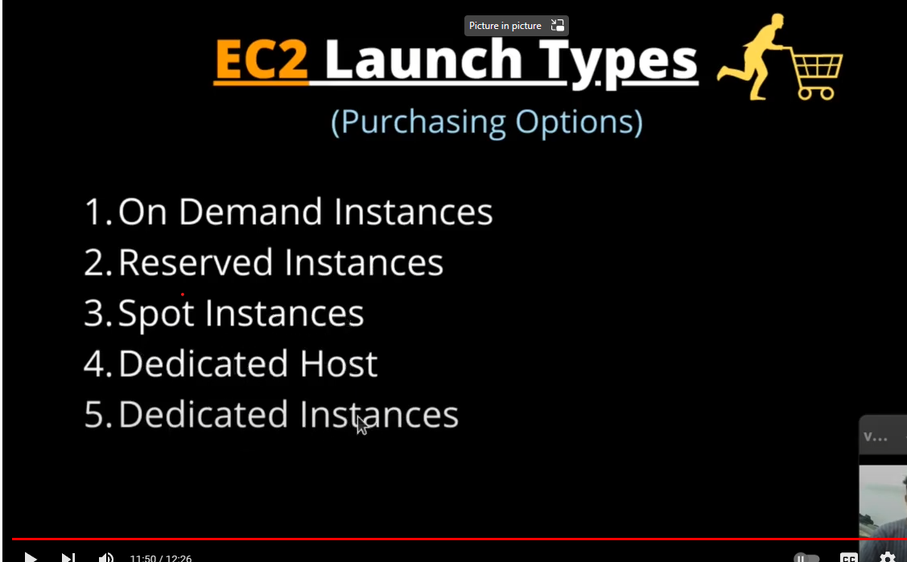

Auto Scaling

\*\*\*\*\*\*\*\*\*\*\*\*\*\*\*\*\*\*\*\*\*\*\*\*\*\*\*\*\*\*\*\*\*\*\*\*\*\*\*\*\*\*\*\*\*\*\*

elastic search:

1. Json based

2. Through RESTFUL API

3.lOGS, Matrics, App trace data

4. compare with relational db:

DB -- Indexes/indice

Tables -- Patterns/Types/Collections

Rows - documents

Columns -- Fields

ELK statck?

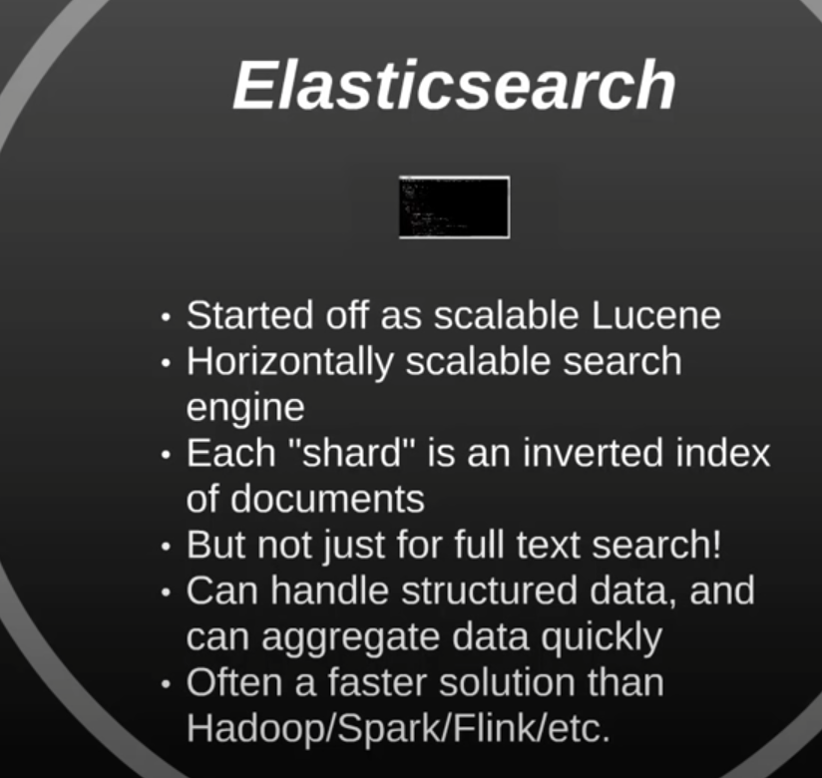

ES

Kibana is a UI dashboard or Widgets/visualizations.

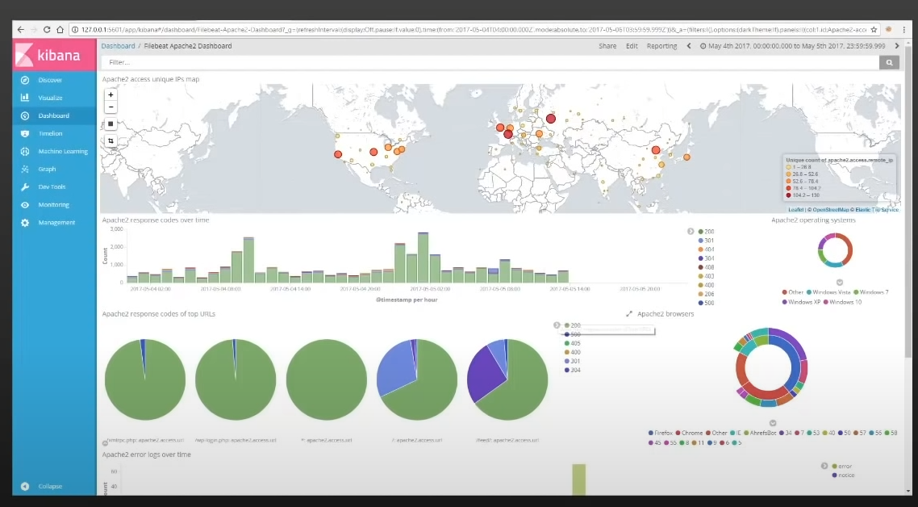

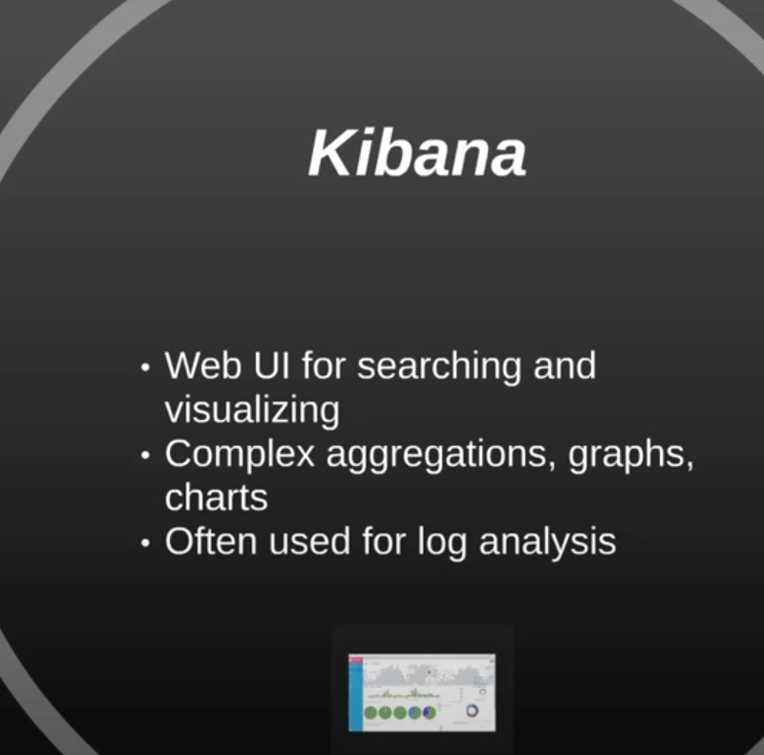

Logstash: is Input of all kinds of data/ Transform/stash

File beat:

\*\*\*\*\*\*\*\*\*\*\*\*\*\*\*\*\*\*\*\*\*\*\*\*\*\*\*\*\*\*\*\*\*\*\*\*\*\*\*\*\*

Cloud computing:

Why: money, reliable, scalabilty

Vendors:Aws, azure, google, alibaba, IBM

Types:

IAAS: server, virtualization, Networking --- OS, Middleware, Runtime, applications, data

PAAS: server, virtualization, Networking, OS, Middleware, Runtime -- applications, data

SAAS: server, virtualization, Networking applications, data, OS, Middleware, Runtime

\*\*\*\*\*\*\*\*\*\*\*\*\*\*\*\*\*MicroServices\*\*\*\*\*\*\*\*\*\*\*\*\*\*\*\*\*\*\*\*\*\*\*\*\*\*\*\*\*\*\*\*\*\*\*\*\*\*\*\*\*\*\*\*\*\*\*\*\*\*

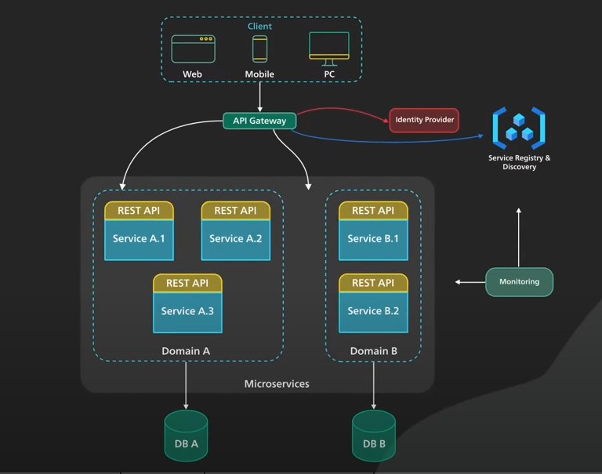

\*\*\*\*\*\*\*\*\*\*\*\*\*\*\*\*\*\*\*\*\*\*\*GateWay\*\*\*\*\*\*\*\*\*\*\*\*\*\*\*\*\*\*\*\*\*\*\*\*\*\*\*\*\*\*\*\*\*\*\*

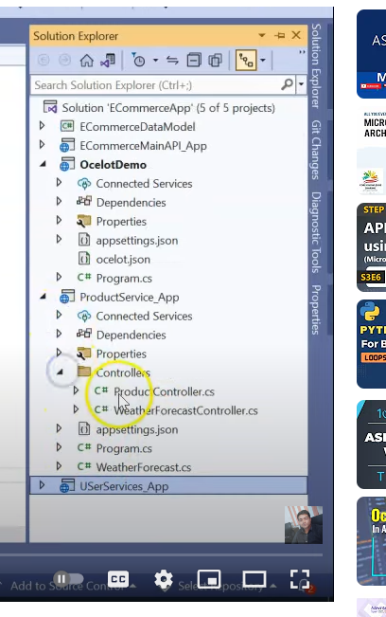

Ocelot:

.Nuget Ocelot

.add config file for dowstreamPateTemplate and upstreamPathTemplate

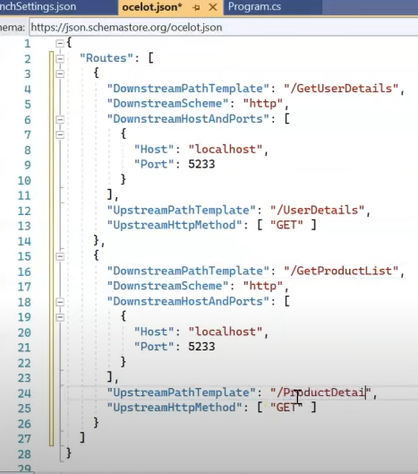

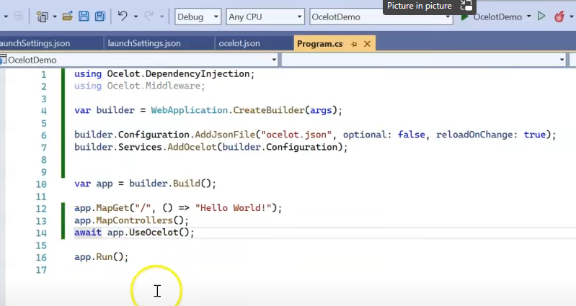

--------- security implementation using ocelot --------------

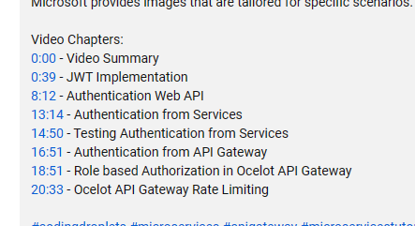

1. 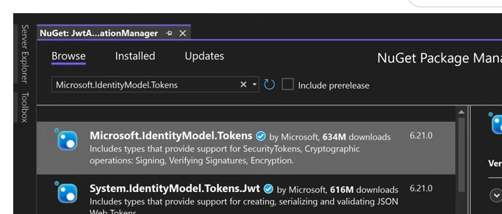
2. 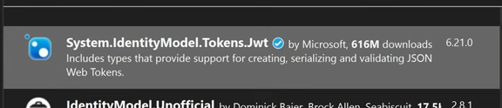
3. 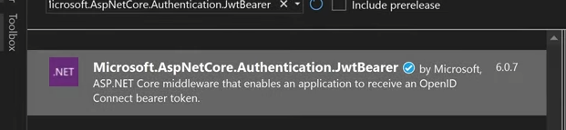
4. Model: UserAccount
5. JwtTokenHandler.cs

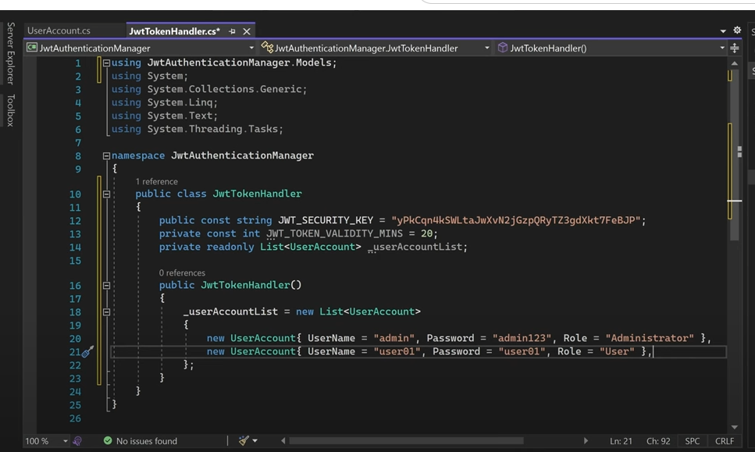



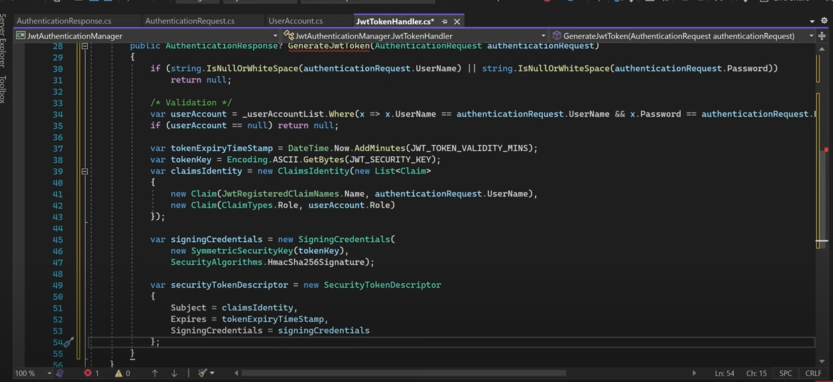

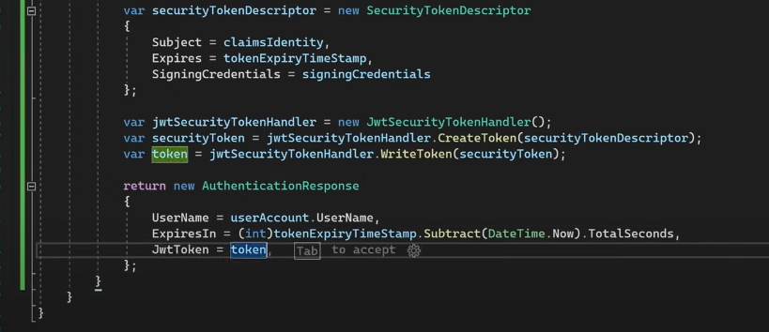

Nuget:

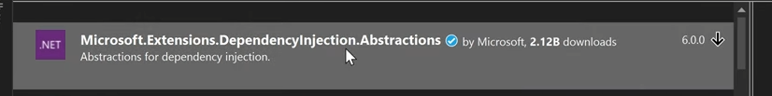

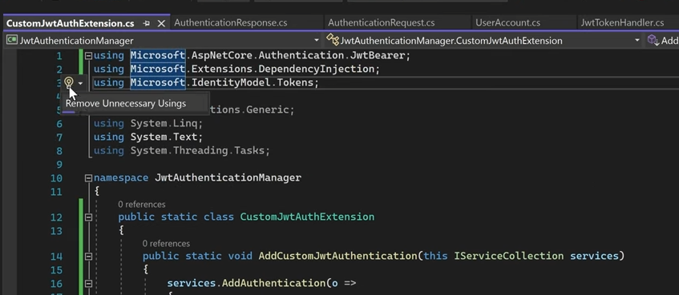

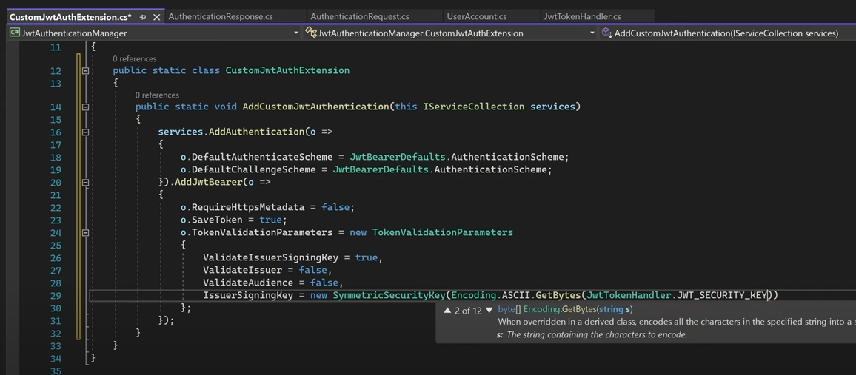

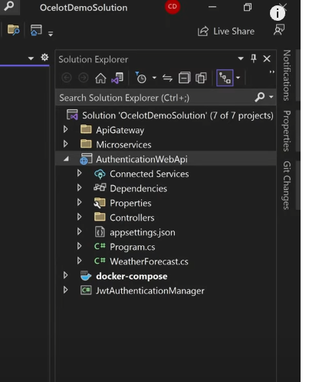

DI:

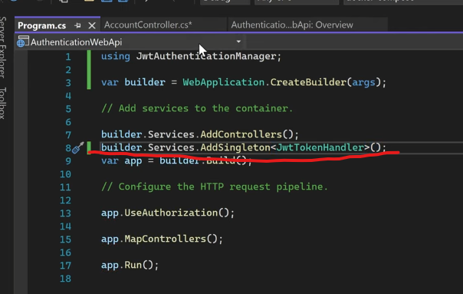

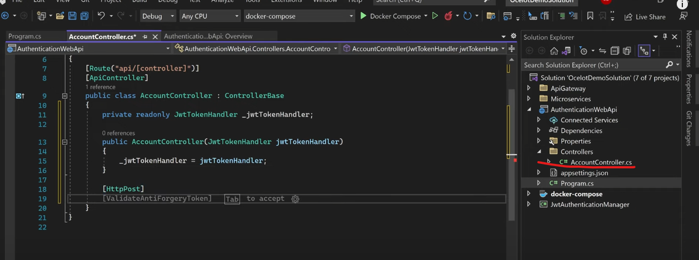

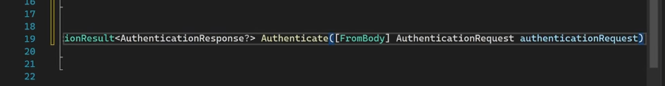

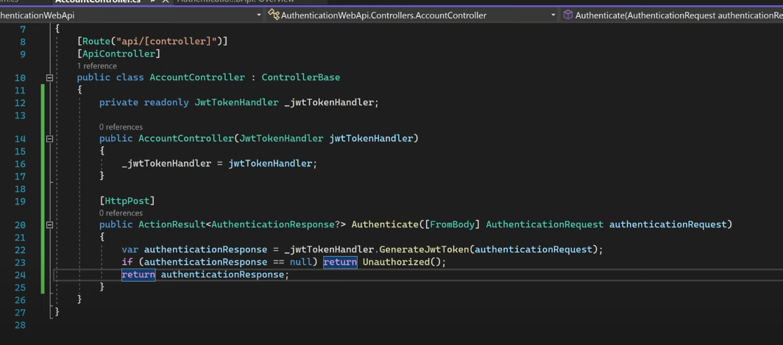

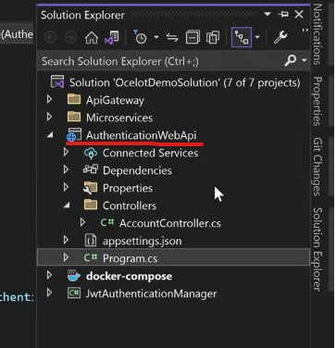

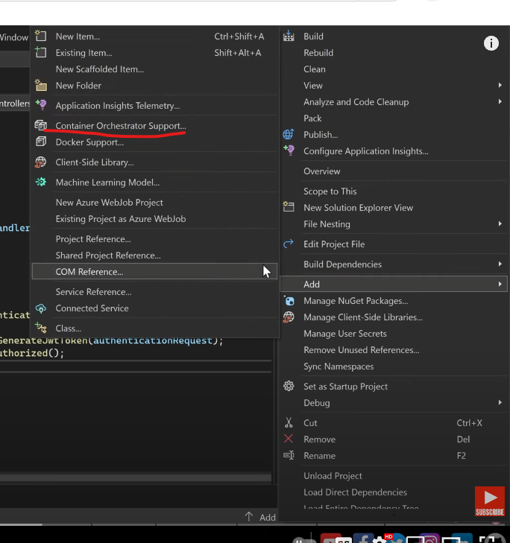

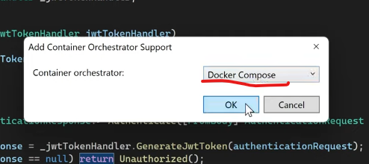

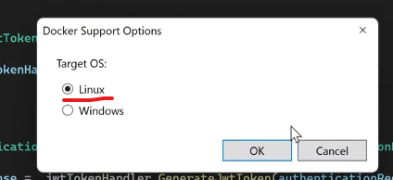

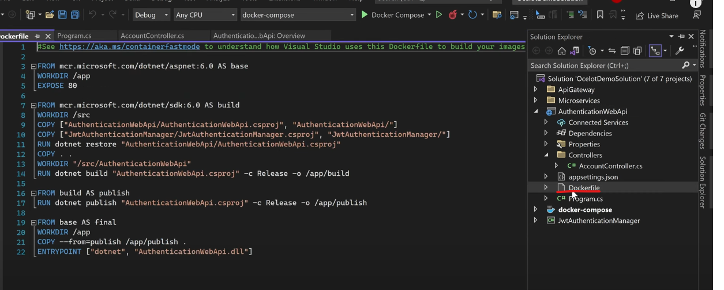

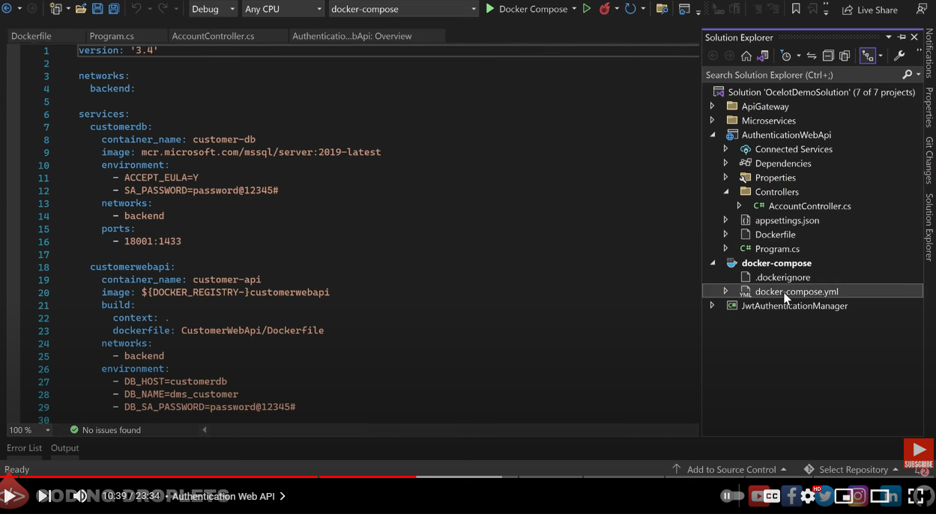

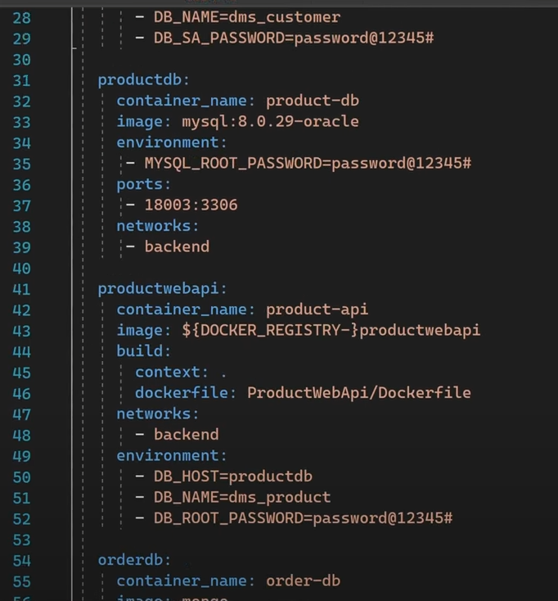

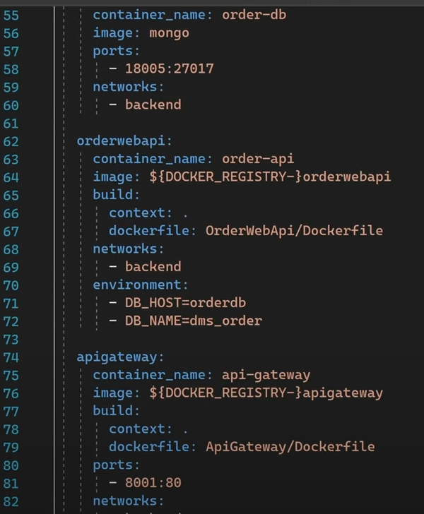

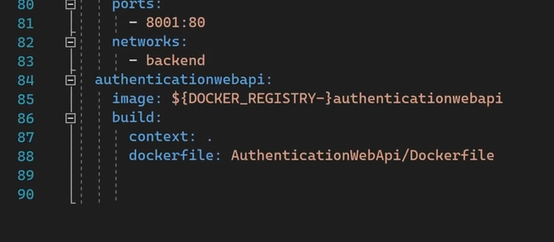

Then, he added in the last section this:

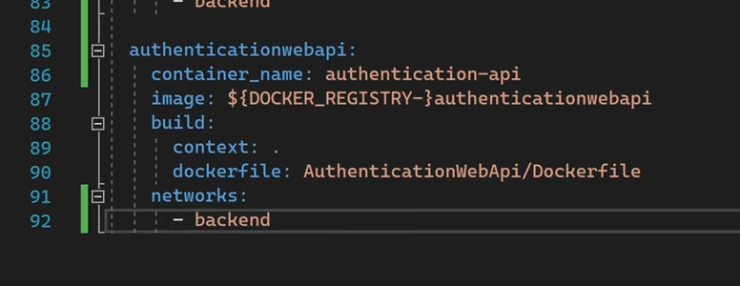

Gateway:

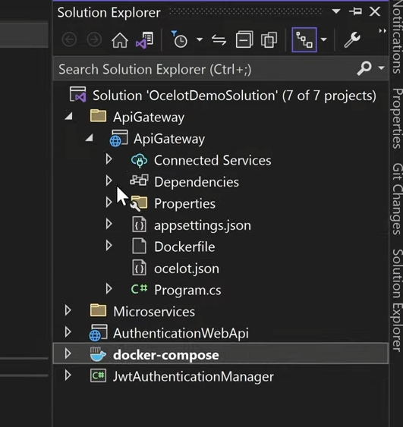

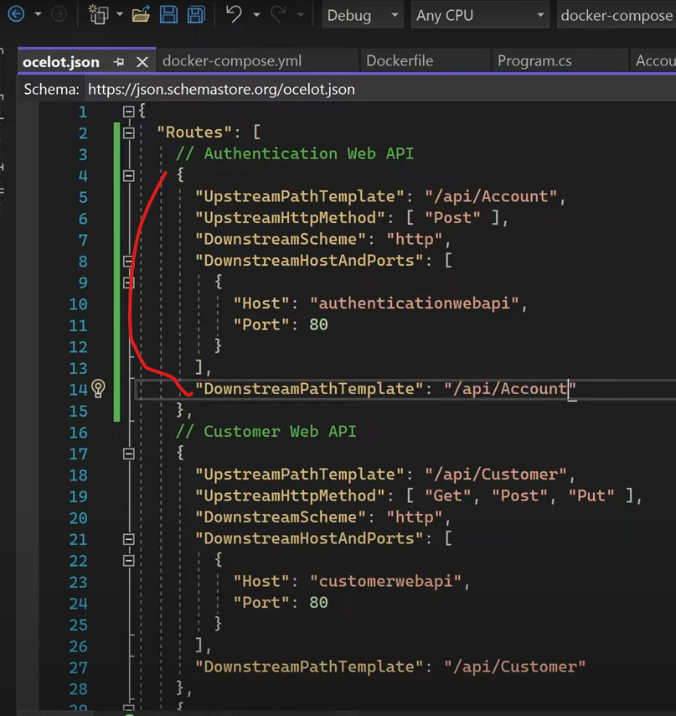

Postman:

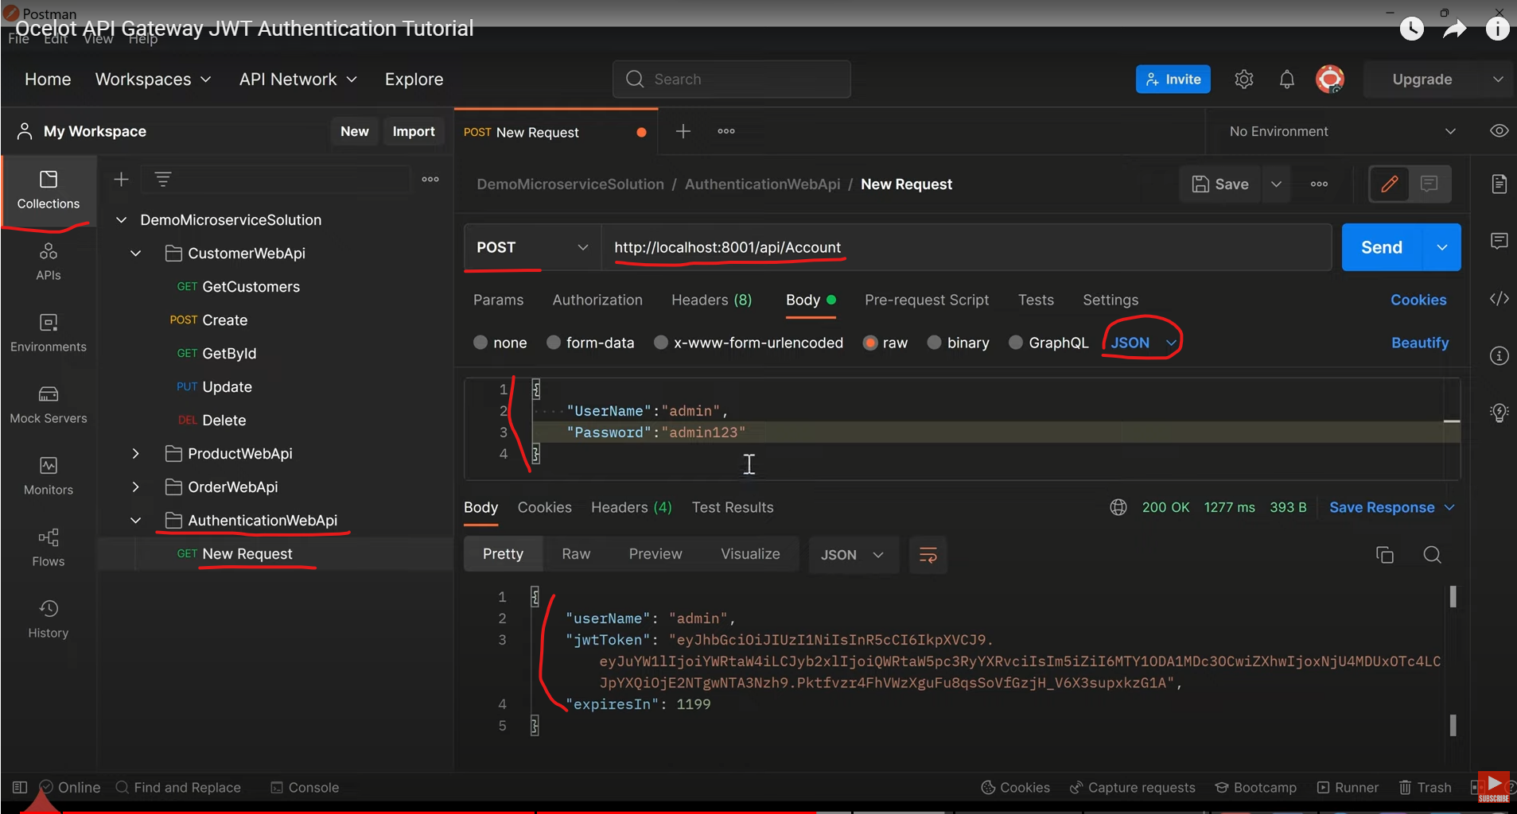

Invalid user:

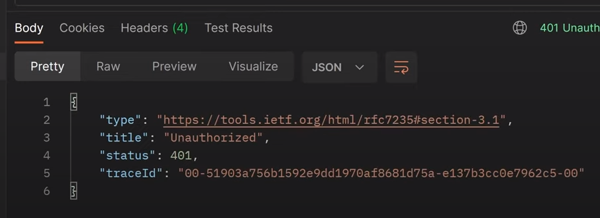

1. Microservices:

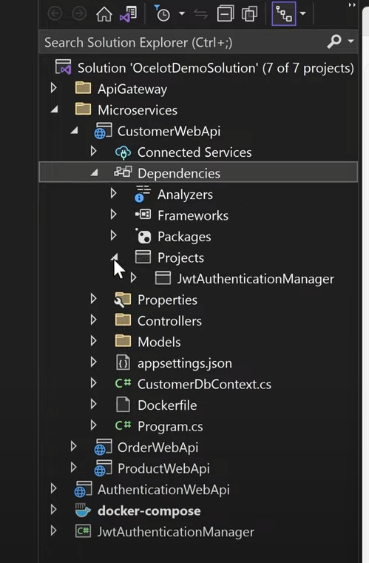

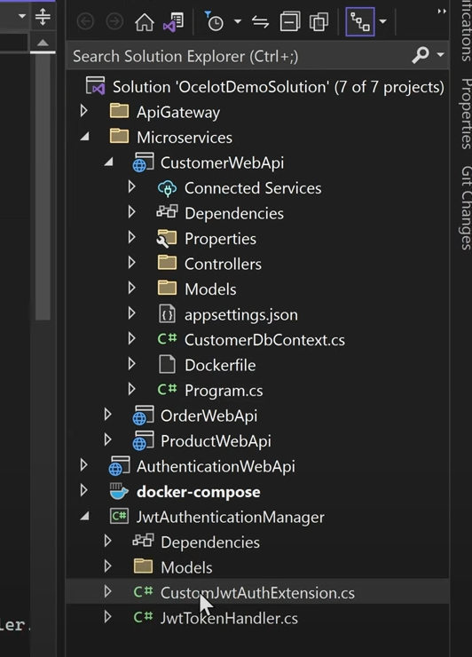

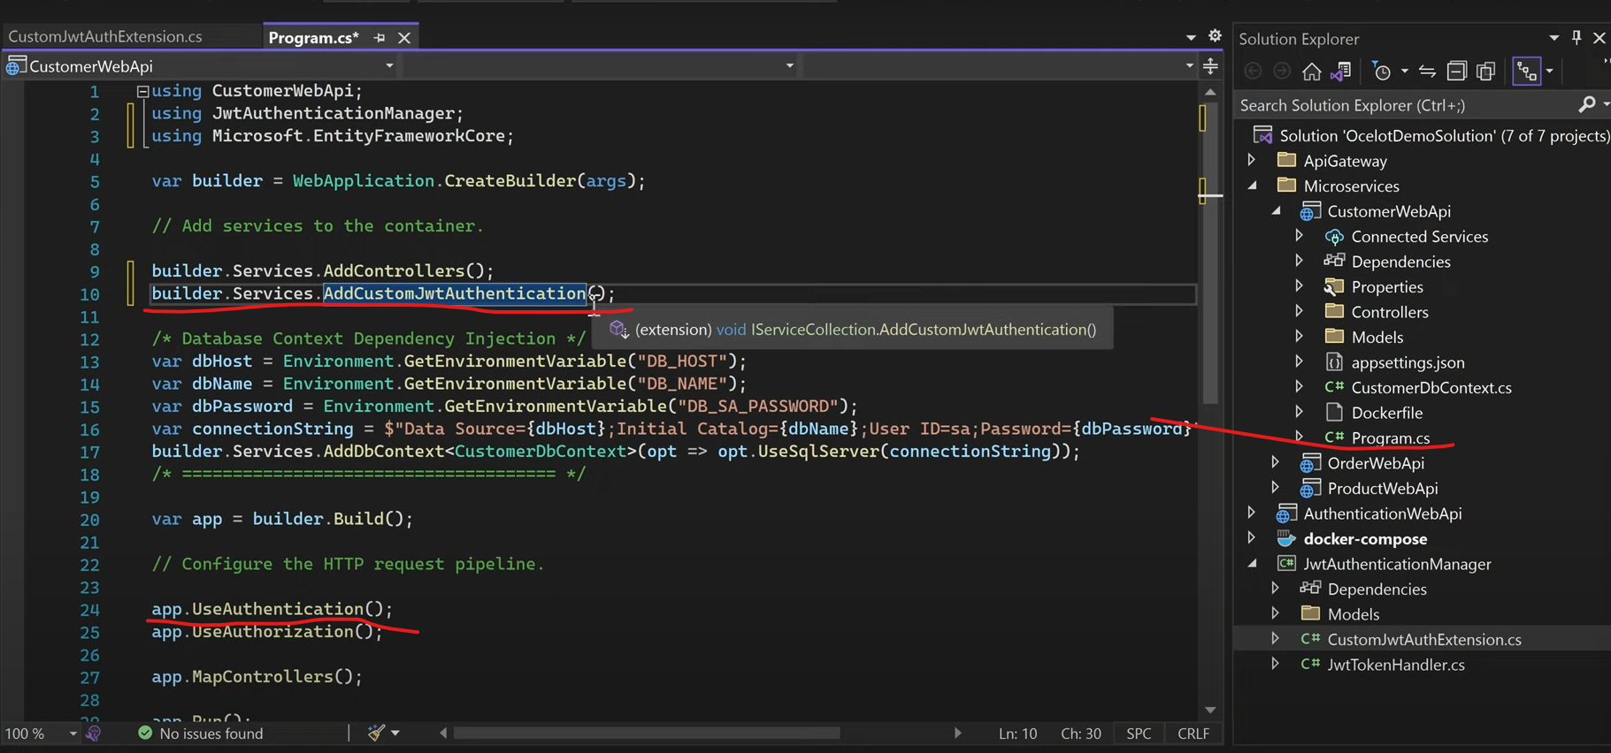

Then add authorize attribute to the microservices controller:

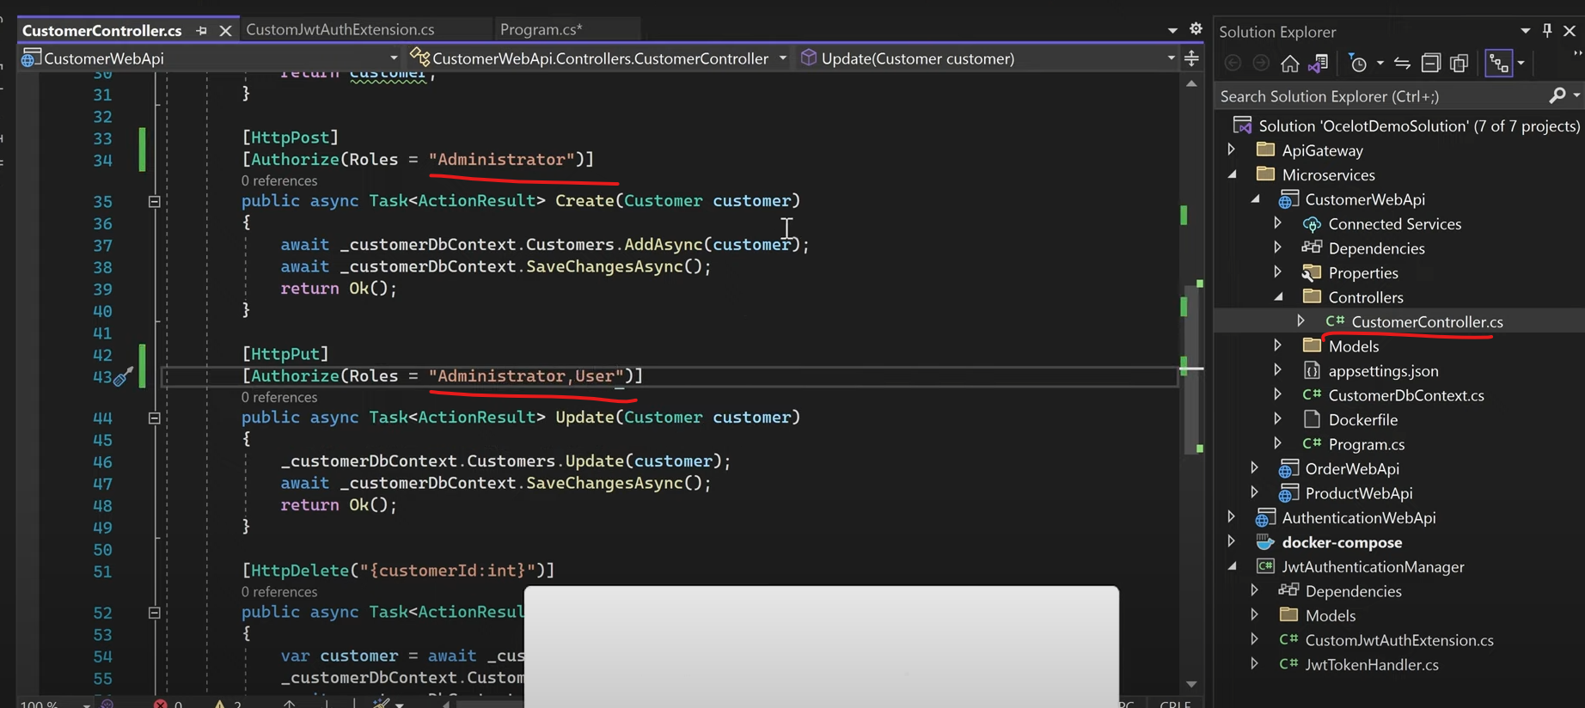

Postman:

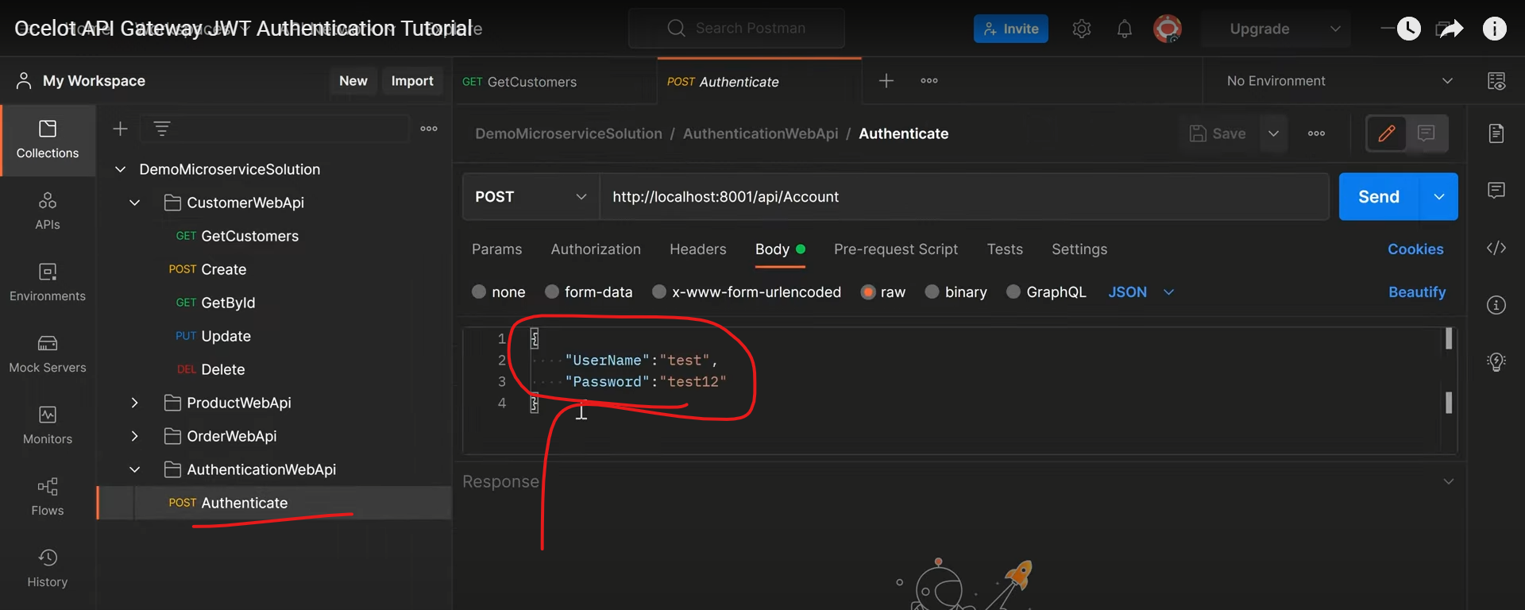

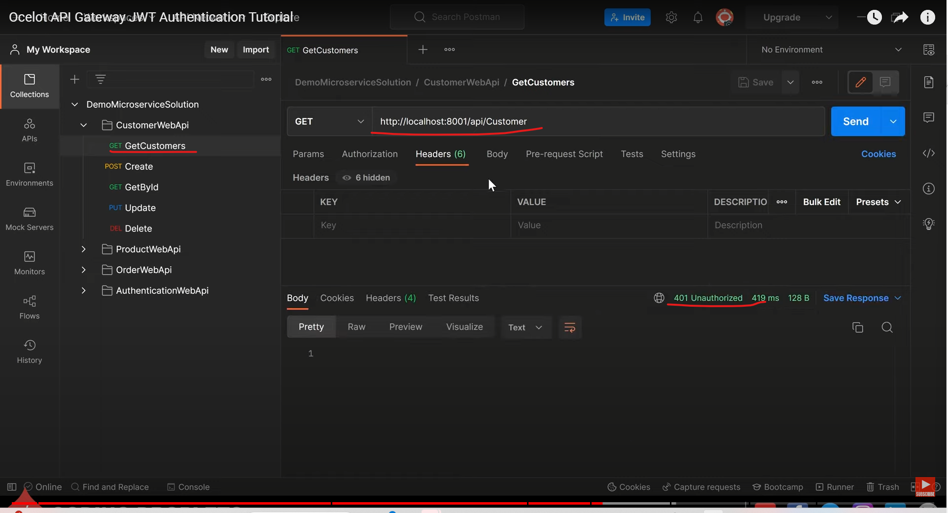

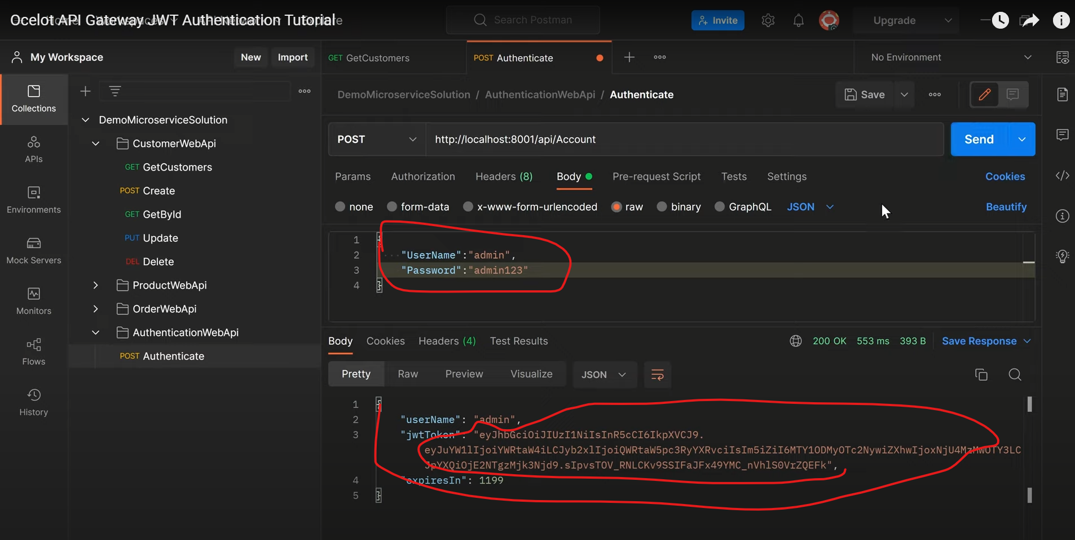

Then back to GetCustomers, paste the token to the VALUE:

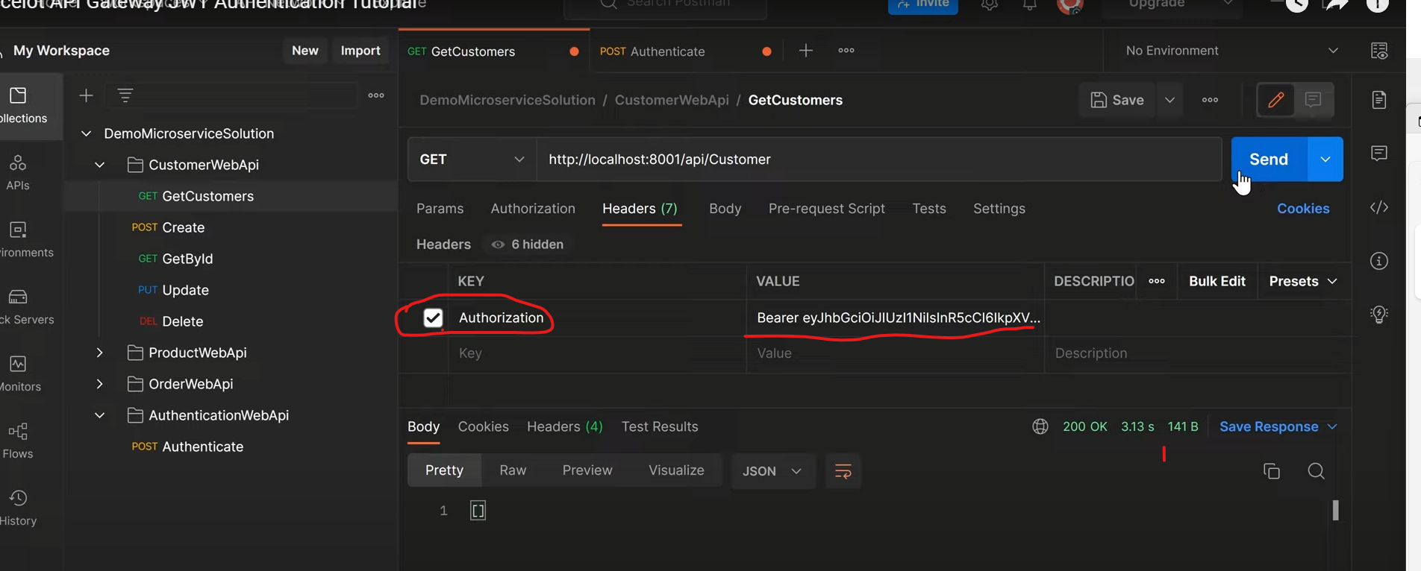

Above return is empty.

Create a customer:

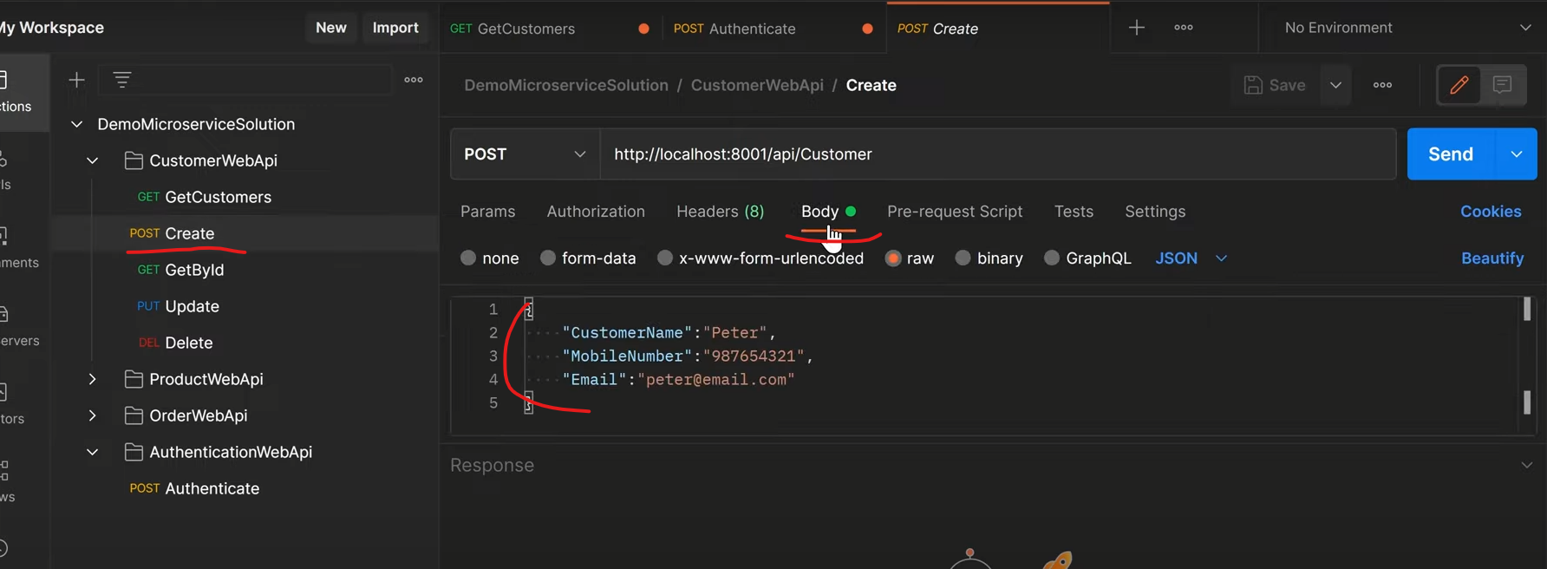

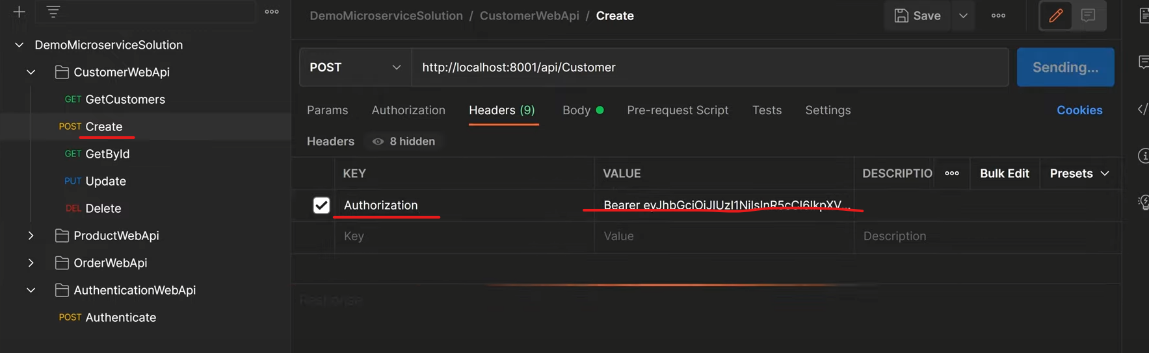

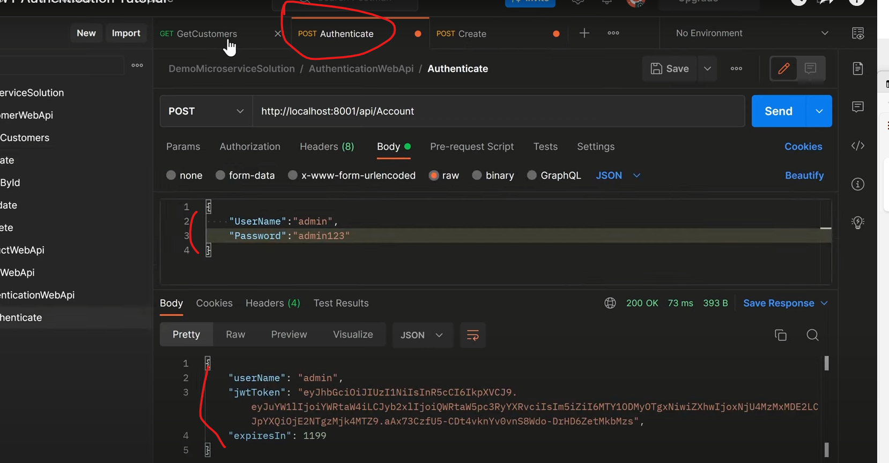

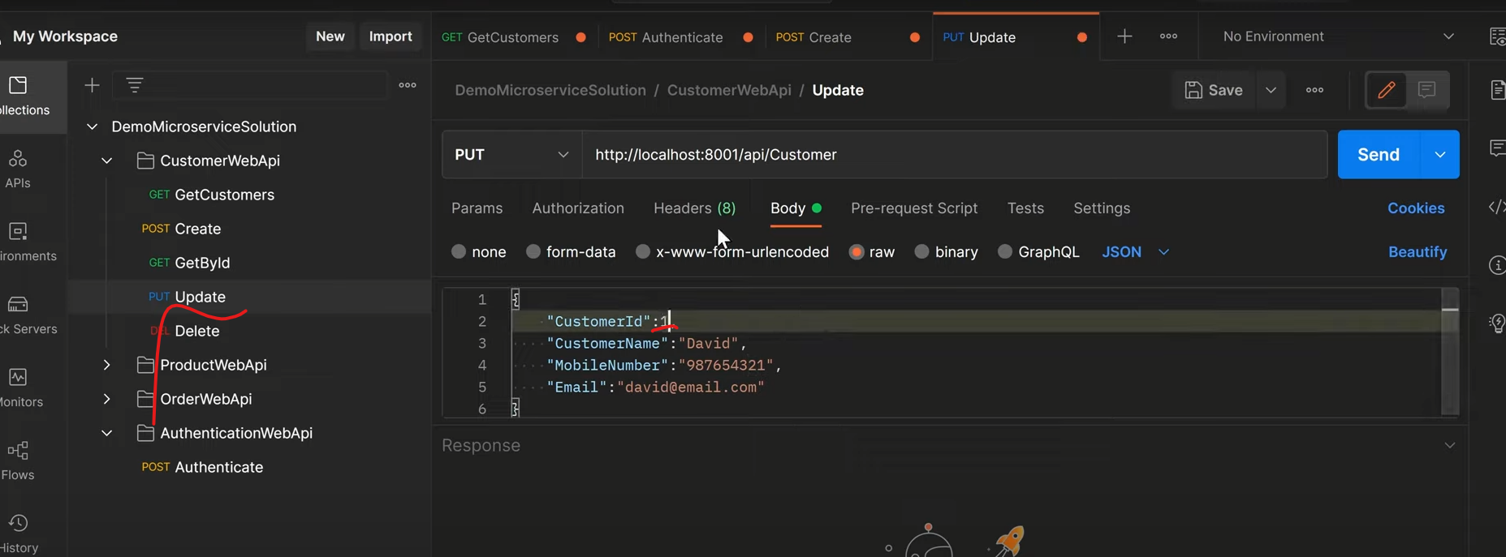

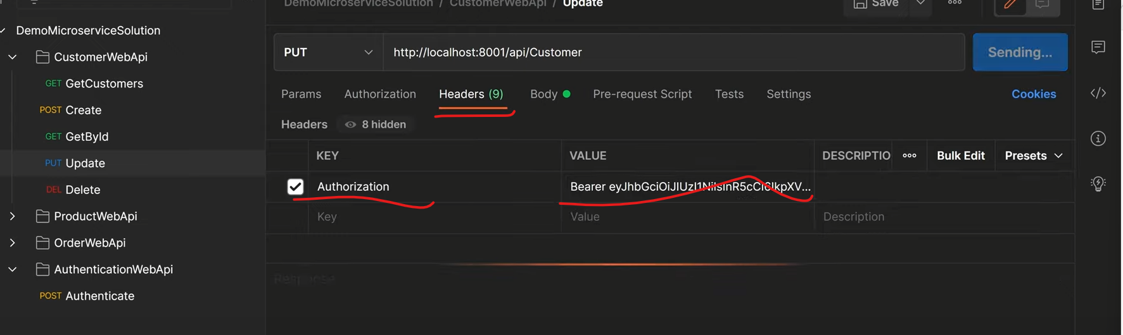

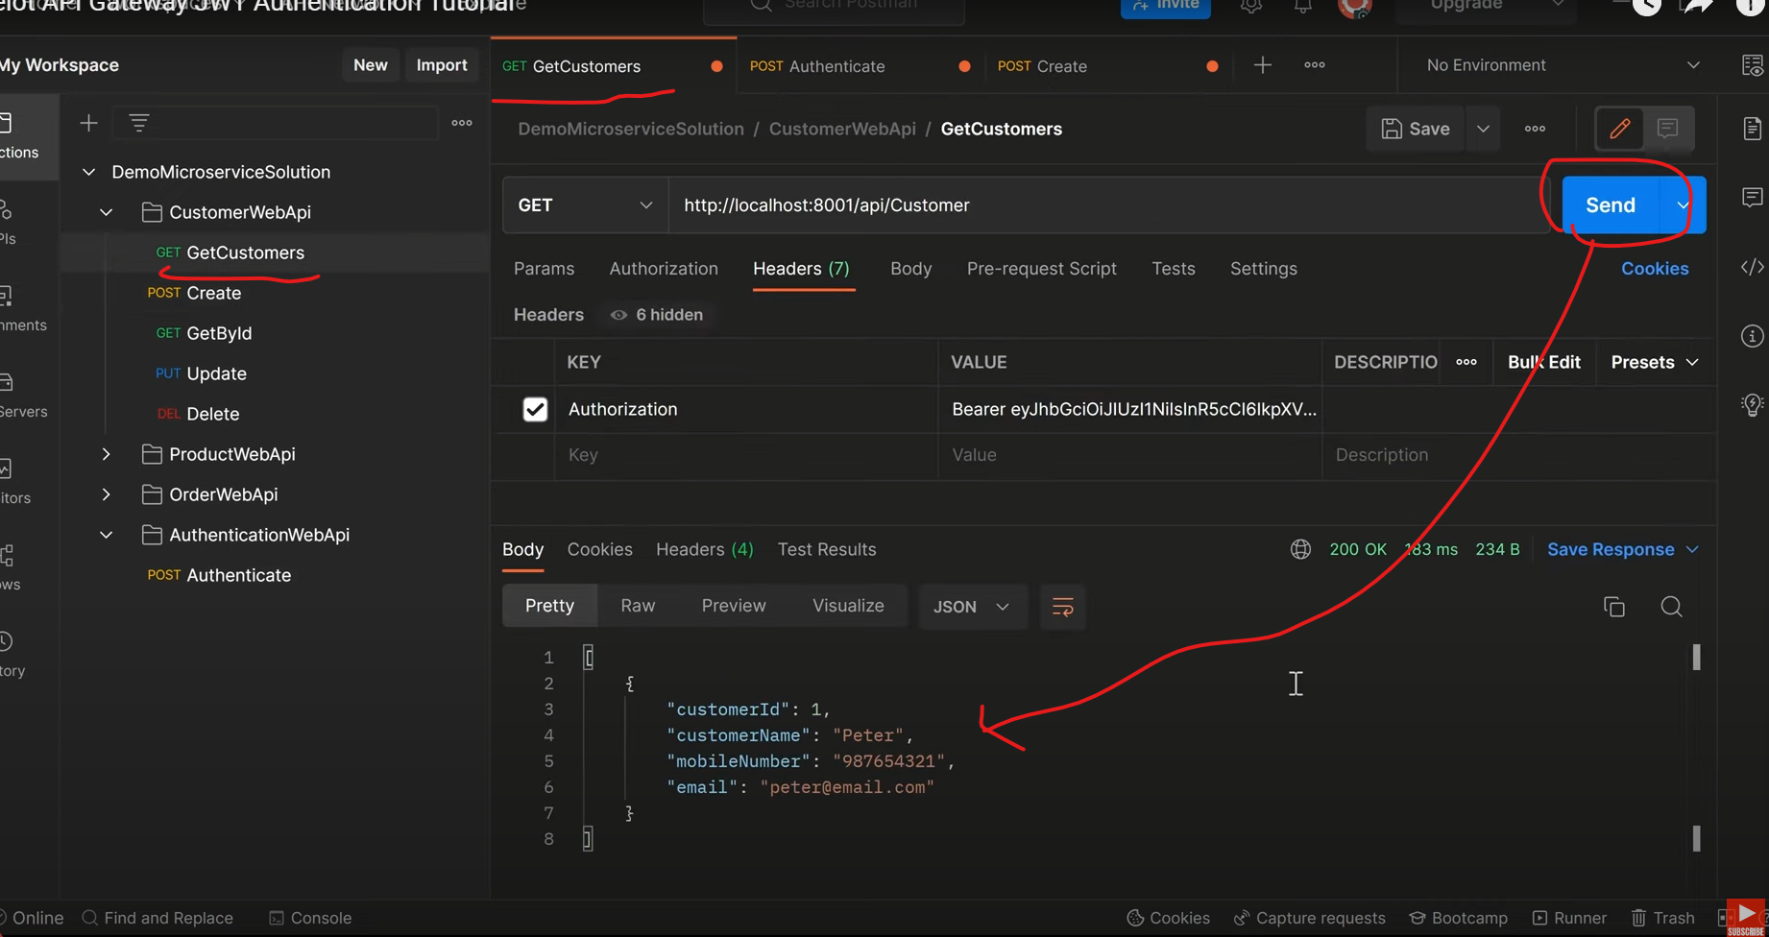

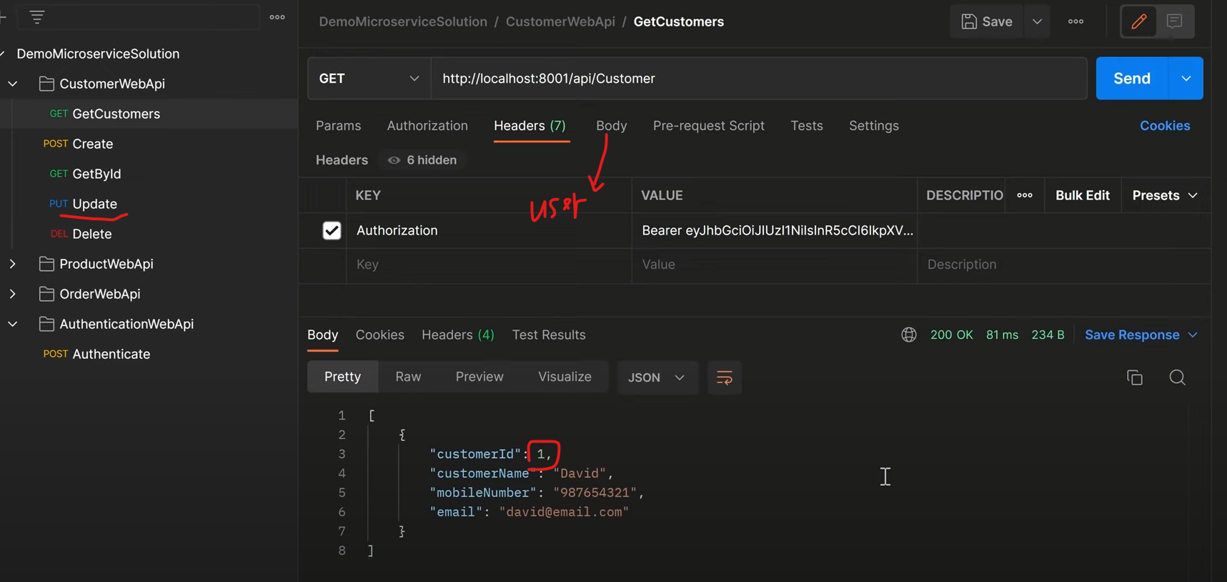

Gateway for ProductWebApi

Implement the JwtToken into ocelet.json config file:

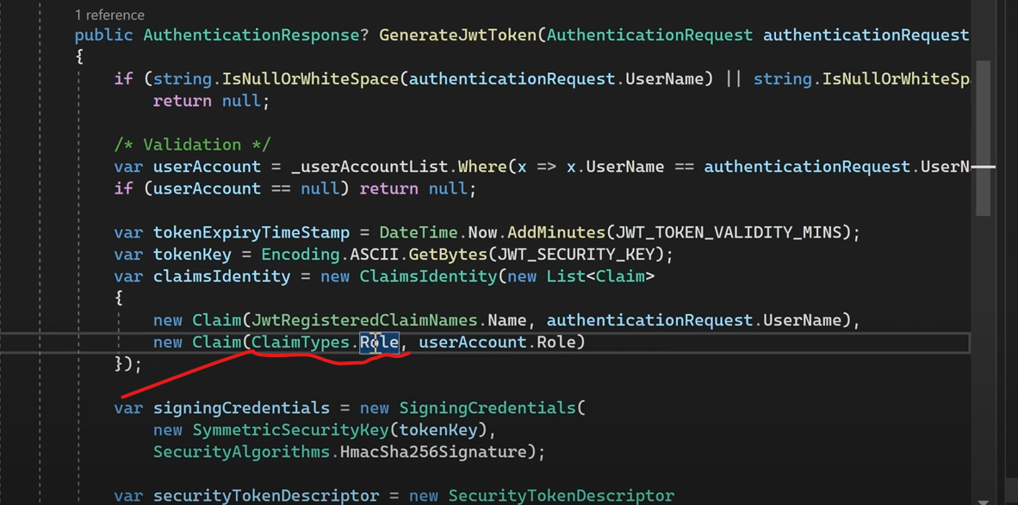

Above is actually a string value

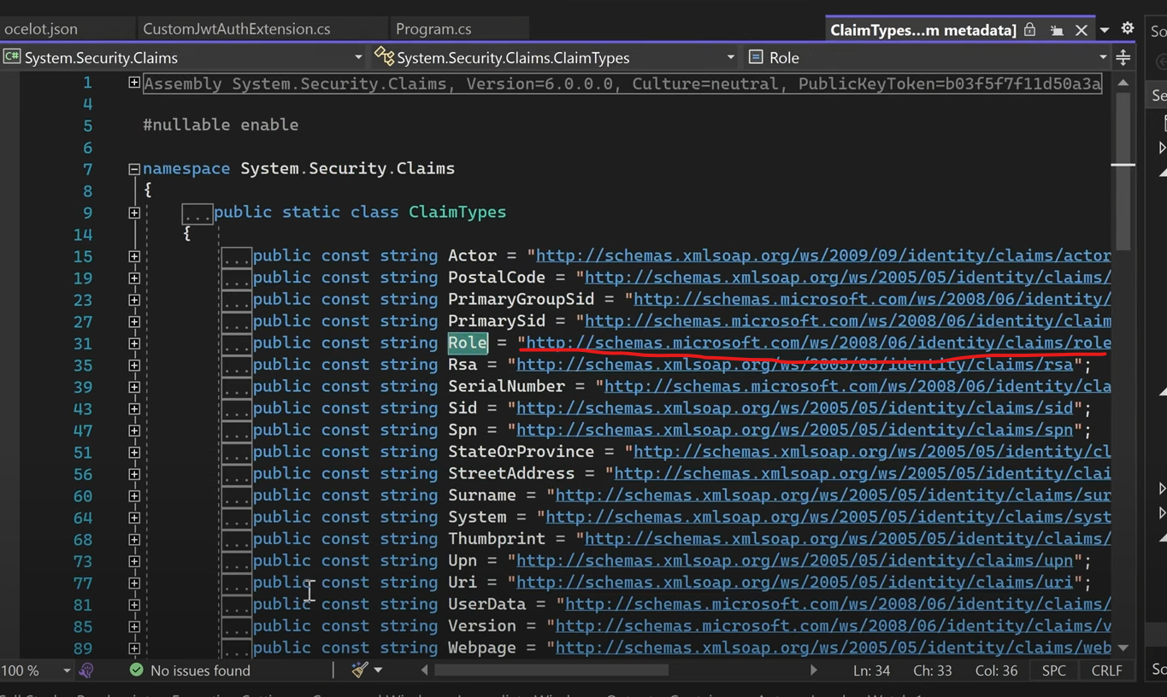

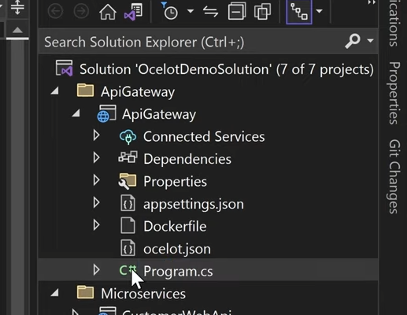

Change that line code into:

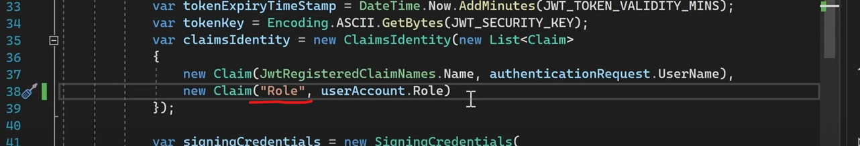

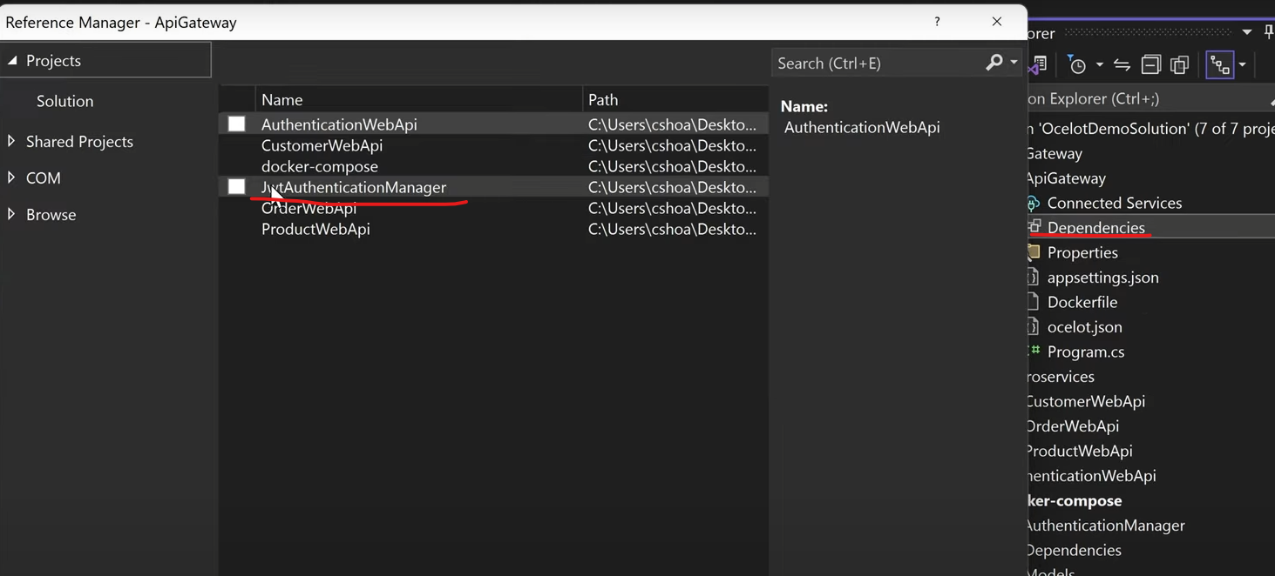

Then, add below to ocelot.json

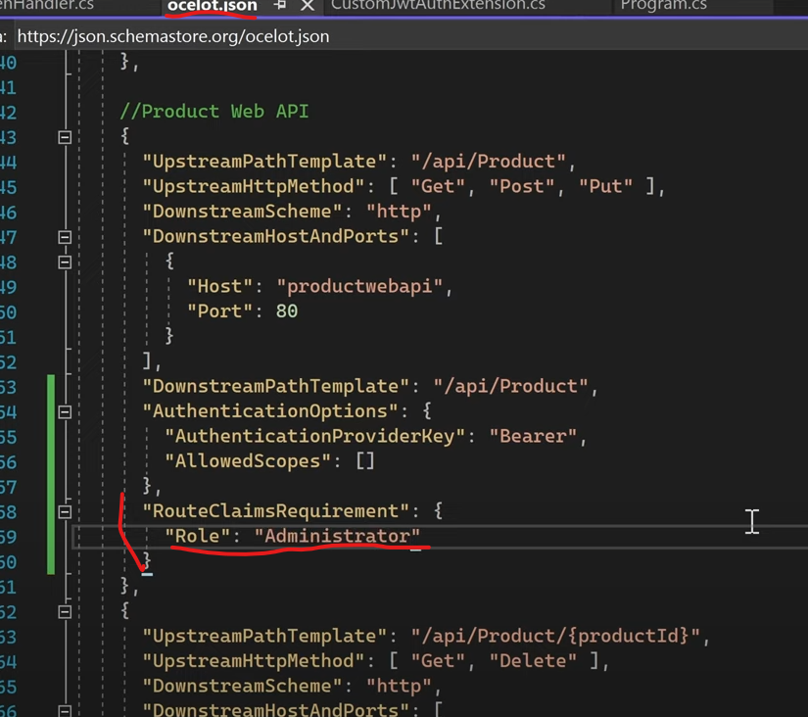

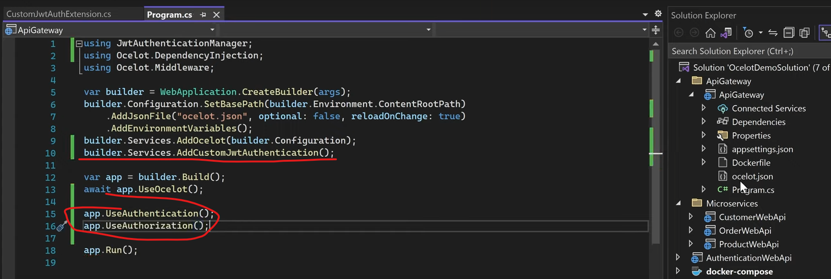

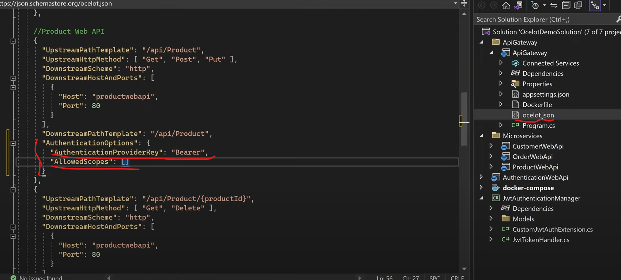

8\*\*\*\*\*\*\*\*\*\*\*\*\*\*\*\*\*\*\*\*\*\*\*Kubernetes\*\*\*\*\*\*\*\*\*\*\*\*\*\*\*\*\*\*\*\*\*\*\*\*\*\*\*\*\*\*\*\*\*\*\*

